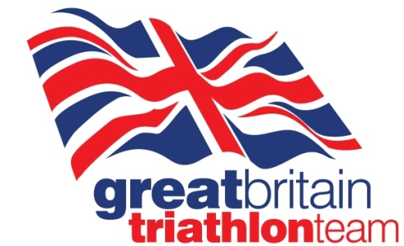
British Triathlon
‘Guide to Gold’
Information and Application form

Could you guide a visually impaired triathlete to Paralympic Gold?
British Triathlon is seeking high calibre female triathlete’s to guide visually impaired athletes at the Rio 2016 Paralympic Games. Paratriathlon makes its Paralympic debut at the spectacular Copacabana Beach in Rio and this is an opportunity to work with the highest calibre athletes in the world.
British female triathlete’s have won four of the last five ITU world titles in the visually impaired sport class (PT5). With less than two years until Rio, an exciting opportunity has arisen to recruit new guide athletes to help the Great Britain team achieve success in Rio.
Applications are welcomed from high-calibre experienced athletes who are not committed to racing in ITU or ETU elite events in the lead up to the Rio 2016 Olympic & Paralympic Games. Those racing in WTC or other none ITU long distance events are eligible to apply, and given the nature of the Rio bike course, strong time trialling ability is an advantage.
Paratriathlon racing takes place over the sprint distance. British Triathlon is seeking a number of guides who not only have good swim speed, but also time trialling ability and ability to run 5km well off the bike. To help guide minimum standards for application, applicants should be able to swim sub 6min 400m, sub 25min 10mile TT, and sub 20min 5km run, however applications from athletes who far exceed this standard are welcome.
The process aims to unearth and identify the very best female athletes across both physical and psychological factors to give us the very best chance of success over the next two years leading into the Rio 2016 Paralympic Games, where the sport will make its debut.
Because the profile of our best VI Female athletes differs, we do not have a single model of person we are looking for, however we will select applicants to assess further in Loughborough on December 18th, based on physical potential and also desire and ability to fulfil the role well.
Please complete the following application form and return to Kirsty Hillier (kirstyhillier@britishtriathlon.org), the Paratriathlon Programme Coordinator by December 10th.
Accommodation can be accessed for those who are selected and require it as part of the process.

Name |  |  | DOB / Age
Address
Personal Bests – please see suggestions opposite; however include others if you feel relevant. |  | Swimming:  400m pool swim:  750 open water:  1500m open water:  Cycling:  10mile TT:  25mile TT:  20km – in Triathlon  Power Output tests:  Running:  3km:  5km:  10km:  ½ Marathon:
Personal Racing Experience – Please give a description of your personal racing history, especially where you think relevant to this role

Personal Motivation – what interests you in this role and why do you think you would make a world class guide

